Atomix – Your Personal Lab with A.I

Kushal D Soni
Department of Computer Engineering, K. J. Somaiya Institute of Technology, Mumbai, India
kushal.soni@somaiya.edu

Dhir M Thakar
Department of Computer Engineering, K. J. Somaiya Institute of Technology, Mumbai, India
dhir.thakar@somaiya.edu

Kartik R Verma
Department of Computer Engineering, K. J. Somaiya Institute of Technology, Mumbai, India

kartik.verma@somaiya.edu

Dr. Madhura Phadke
Department of Computer Engineering, K. J. Somaiya Institute of Technology, Mumbai, India
madhura.phadke@somaiya.edu

Abstract— Chemistry education challenges learners to connect what they see in experiments with what happens at the molecular level and in other forms of representation, which is not easily achievable through traditional laboratory activities alone. Existing solutions rely on isolated applications of virtual laboratories, games, VR, or AI, and allow us to create the chemistry education environment based on various technologies. The study introduces Atomix as a Unity virtual chemistry laboratory that alters traditional teaching with the help of interactive experimental processes, 3D visualization, conversational AI assistance, and assessment as a part of one application.
Atomix is compatible with Meta Quest and OpenXR technologies in VR and keyboard-and-mouse interaction and encompasses eight experiments in the field of inorganic chemistry, ten theory assessments, relevant educational videos at molecular level, experimental documentation, and audio guidance. The AI voice-controlled Lab Assistant is developed with the help of Inworld AI SDK and performs various tasks related to chemistry via voice and text.
The prototype allows us to demonstrate a full experiment cycle on two platforms, randomized experiments and theory assessments, as well as the sodium-water experiment on the quantity-of-substance basis.
Keywords—virtual chemistry laboratory, Virtual Reality, educational technology, chemistry education, Artificial Intelligence, game-based learning, immersive learning.

- Introduction
Chemistry is an essential branch of science that requires learners to grasp the process of chemistry at various levels, that is, from the macroscopic level of observed changes in the chemical reactions performed in laboratories to the chemical equation level involving chemical symbols and formulas. The abstract nature of these concepts makes chemistry difficult to teach or learn since students are called to relate the observations made in laboratories and the processes that cannot be perceived directly. Therefore, the option to combine practical and virtual lab experiences has been studied in connection with chemistry teaching and learning.
Educational games have also emerged as an option that makes learning interactive and enjoyable. Digital games can provide learners with learning objectives through games that require them to do things and receive information and knowledge on how to do about problems. Chemistry has been one of the key fields for experiments with educational games because the concepts like atoms, molecules, chemical bonds, and reactions can be taught through visual and game elements. The effectiveness of puzzle-based games has been proved in teaching chemistry concepts [2]. In chemistry laboratory instruction, gamification has also been utilized to demonstrate how game-based activities can help students stay motivated, learn, communicate, and cooperate. [3]
Virtual labs represent a different method of helping chemistry education because they make it possible to recreate laboratory processes and experiments in controlled cyberspace. Indeed, students can interact with laboratory equipment and perform experiments without being exclusively dependent on the availability of physical laboratory facilities. The use of conventional and virtual laboratory methods was studied in undergraduate chemistry education showing the potential of virtual worlds to complement standard laboratory experiences. [1]
Advances in virtual reality (VR) technology have furthenctionality of the virtual educational environment by enabling the users to interact in real time with three-dimensional laboratory rooms and objects. The application of VR in the field of chemistry and chemical engineering has been studied in terms of the use of virtual laboratory setups, the visualization of complex processes, and the simulation of events that are not feasible in the traditional educational environment [4]. Systems for immersive molecular visualization were created to give users an opportunity to work with three-dimensional molecular structural materials. The realization of information becomes more effective, as the two-dimensional methods are not efficient for this purpose [5]. The most recent experimental research was dedicated to the study of immersive VR as a teaching tool, and it was concluded that immersion must be assessed in terms of its impact on results rather than as a measure of effectiveness [6].
The field of education incorporates not only immersive technologies but also artificial intelligence (AI) via conversational agents, chatbots, and smart tutoring methods. AI educational assistants help students understand concepts better, facilitating the process of learning and interacting with the system in natural language. Previous research showed that the use of AI chatbots increases learning in higher education, illustrating the importance of chatbots in education [7]. Nevertheless, the educational impact of such solutions largely depends on how well the system achieves the goals of the learning activity.
Even though educational games, virtual laboratories, immersive VR systems, and AI-powered learning environments have already been analyzed, these technologies are considered mostly separately or with regard to certain elements of educational process. In addition to that, educational games are in need of scientific evaluation of their usability and educational effectiveness rather than being analyzed only like conventional software programs. Conducting systematic reviews of various methods of evaluating educational games states the necessity of evaluating educational value through the use of appropriate means of measurement.
In order to harness this opportunity, this research introduces Atomix - a virtual laboratory for chemistry, developed using Unity. Atomix is focused on providing an interactive learning environment in the field of chemistry through VR technology with Meta Quest or OpenXR and also through the interaction using keyboard and mouse desktop systems. The Atomix is composed of eight practical inorganic chemistry experiments and ten theoretical assessment exercises with videos explaining the processes at the molecular level, audio instructions throughout the process, and a voice AI Lab Assistant powered by Inworld AI. The analysis of the project indicates that Atomix comprises all these elements and is a four-scene Unity application providing both immersive and classical interaction.
This research aims to study the design and educational potential of an integrated virtual laboratory in chemistry where an interactive experiment is done through immersive visualization, AI-supported interaction and assessment. The study mainly emphasizes the design of Atomix and its evaluation with respect to usability, learning support and user experience. The next sections of the paper present theoretical background and previous works, the methodology, implementation of Atomix and evaluation findings and discussion.
- Theoretical Background
A. Chemistry Education and Multiple Representations
Chemistry refers to notions existing at numerous representation levels. Students are supposed to observe lab phenomena and comprehend molecular processes as well as their natural descriptions. That is why employing many representations is beneficial for chemistry classes since it assists students in bridging the gap between macro and micro dimensions of the chemical reaction [9]. Also, the process of switching from one representation to another may be complicated due to the fact that in a regular laboratory setting, students do not see molecular processes at work [10].
Accordingly, there have been studies in the use of technology-based visualization as a way of helping people visualize chemical structures and processes. With the help of interactive visualizations, students can study molecular structures from different angles and manipulate the representation that remains abstract otherwise. This approach sets up the path for virtual immersed learning, in which molecular phenomena are available together with experimental evidence [9], [10].

B. Game-Based Learning and Serious Games
In Game-based learning, the learning objectives are blended into interactive actions where learners are given chances to act, choose, obtain reactions, and achieve goals. Serious games take this further, where games are used for purposes other than entertainment like education and training. The impact of using educational games does not only rely on the presence of those games but also what game mechanics have been used [11].
Game-based methods have been studied as a means of increasing learning participation and activity within the context of the teaching of science and chemistry by allowing students to practice and repeat crucial concepts many times. The games used in the teaching of chemistry deal with the topics of chemical structures and bonds, chemical reactions and laboratory practices among other subjects. Previously conducted studies showed that educational games produced under the conditions of modern playpedagogics have become a powerful representation of chemistry concepts [2], [3]. Systematic research on serious games has shown that when creating educational games it is also crucial to consider such factors as setting clear objectives for learning, giving feedback, usability, and evaluation of the educational game [11].
Game-based learning for Atomix is manifested through interactive laboratory activities in which students choose experiments, control virtual lab tools, conduct chemical procedures, get instant feedback, and carry out practical or theoretical evaluation tasks. Therefore, the gaming mechanics are related to chemical education activities rather than only acting as an outside incentive system.
C. Virtual Chemistry Laboratories
It is possible to explain practically and in detail laboratory apparatus, use of it and the scientific results of experiments in the so-called virtual laboratories. Virtual laboratories may be used as additional facilities for conventional laboratories in that students are able to repeat the experiments more than once in a virtual laboratory and do the experiments that would be impossible to conduct due to the limited conditions [1], [12].
Research into the use of virtual chemistry laboratories has been primarily concerned with educational aspects of virtual laboratories, their characteristics and advantages in comparison to traditional research laboratories from pedagogical perspective. It should be noted that their usage allows conducting experiments that could have not been performed in traditional laboratories.
Atomix adopts a virtual laboratory approach, exhibiting the laboratory tools and substances as interactive three-dimensional entities. Students choose a reaction of interest and then select the necessary apparatus, manage the containers, pour in the substance, and watch the reaction through the process. The software also offers experiment sheets and audio steps for executing laboratory work.

D. Virtual Reality in Chemistry Education
Through the use of virtual reality (VR), traditional forms of virtual learning are broadened by introducing new ramifications of 3D immersive interactions. In contrast to simply watching the laboratory via a traditional interface, learners are allowed to enter and transmit through the virtual laboratory managing various objects in spatially intuitive ways. Additional research is available which reflects the application of VR in chemistry and chemical engineering education, including the visualization of various processes and lab settings.[4],[13].
Immersive environments are also capable of helping visualize molecular structures and processes that cannot be effectively visualized using standard laboratory equipment. In fact, interactive molecular visualization systems already provided evidence that such environments can give learners the opportunity to manipulate and to study three-dimensional molecular structures [5]. More recent research conducted in the experimental context has proved once again that rather than simply relying on the assumption that higher level of immersion leads to improved learning, a need exists to empirically demonstrate that immersion actually leads to better educational results [6].
The primary interaction mode used by Atomix is VR, which is enabled by Meta Quest and OpenXR. Atomix is set up as a 3D environment, wherein users can manipulate objects by grabbing them, moving them, or tilting them. There is also the option of utilizing a keyboard and mouse alternative, which allows access to the same 3D environment without using a VR headset. This combination of VR technology and a desktop alternative has been made with the intention of increasing the number of users able to participate in the system.

E. AI-Assisted Learning
Educational systems featuring artificial intelligence components are becoming more common these days. They include intelligent tutoring systems, conversational agents, and AI chatbots. These systems are able to give learners methods of quickly responding to questions with answers in natural language. AI in education entails research concerning techniques for providing learners with conversational systems [7], [14].
As part of this AI-facilitated learning experience, it is essential to understand how conversational systems correlate with learning activities. The work of an AI assistant takes place independently from the educational process, where it only provides general information while not accomplishing anything practically. By contrast, involvement in a tutoring process can potentially help learners right at the point at which they feel confused or have some challenges executing a task.
Atomix incorporates a voice-based AI Lab Assistant using the Inworld AI SDK. Users can activate push-to-talk interaction, ask chemistry-related questions using speech, and receive responses through both generated voice and a text-based dialogue interface. The AI component therefore functions as an additional source of instructional assistance within the overall Atomix ecosystem rather than replacing the laboratory activities.

F. Synthesis and Research Gap
Based on the literature, several complementary strategies have been explored to enhance science and chemistries learning. Approaches based on multiple representations overcome the barriers of the interrelation of observable concepts and molecular level concepts [2][3][11], gaming in education provides learning through interaction and feedback [1][12], virtual laboratories create the opportunities to conduct experiments in the controlled environment [4], immersive VR provides three-dimensional interaction and visualization [6][13], while the AI-based education systems enable students to communicate with a tutor [5][14].
Yet, such areas of investigation do not provide a comprehensive learning environment. Nevertheless, Atomix application combines virtual experimentation, explanatory molecular content, VR interaction, desktop access, AI assistance, and assessment in one application. Thus, the investigation is of how to combine these components into a single chemistry education experience.
This study intends to focus not only on the technical implementation of the virtual laboratory, thus ensuring its usability and academic potential.
This is the basis of the research methodology presented below.

- Proposed Method
A. Proposed Development Methodology
Atomix utilizes a sequential approach in the overall development process, which aims to convert the requirements of an educational chemistry app into an interactive laboratory environment. The approach comprises analysis of requirements, design of systems, creation of a three-dimensional laboratory, design of the interface of users, implementation of chemical reactions, integration of AI in the system, and testing and releasing it. The general process is represented in Fig.1.

The first step is to analyze the educational and functional needs of the system. The main requirement is to create an interactive environment for students to conduct chemical experiments without a real lab. Among the additional requirements one can name the presence of different chemistry experiments, educational instructions, visualization на molecular level, testing, and chat-bot help.
The second stage has to do with designing the virtual laboratory and its structure for interaction. The system is made up of three-dimensional laboratory environment, replete with the necessary virtual laboratory tools and objects that are specifically used in reactions. The design of interactions takes into account both immersive VR interaction and regular keyboard and mouse interaction, allowing the same laboratory environment to be reached through different modes of input.
The third stage involves creating the chemistry laboratory environment and acknowledging how reactions happen. Experiments can be created using reaction logic and interaction scripts. The reaction system allows for finding out the conditions under which any reaction can be performed and produces corresponding results, such as animations, sounds, and information on the chemical equation. This project implies eight possible reactions in inorganic chemistry.
The fourth stage is about adding educational features to Atomix. They imply having available instructions, step-by-step audio instruction, videos explaining the molecular level, random tests, and AI lab assistant. AI assistant is made available through Inworld AI software development kit and gives user the possibility to talk to the assistant.
The last stages encompass testing and implementation. The objectives of testing include the evaluation of interactions within the experiments, the triggering of an emotional response, laboratory navigation, interactions on the desktop, the functionality of the VR system, the realization of the assessments, and the interaction with the AI system. The operating system that is created is suitable for Meta Quest/OpenXR VR; it also ensures desktop functionality in Windows with the help of a keyboard and a mouse.
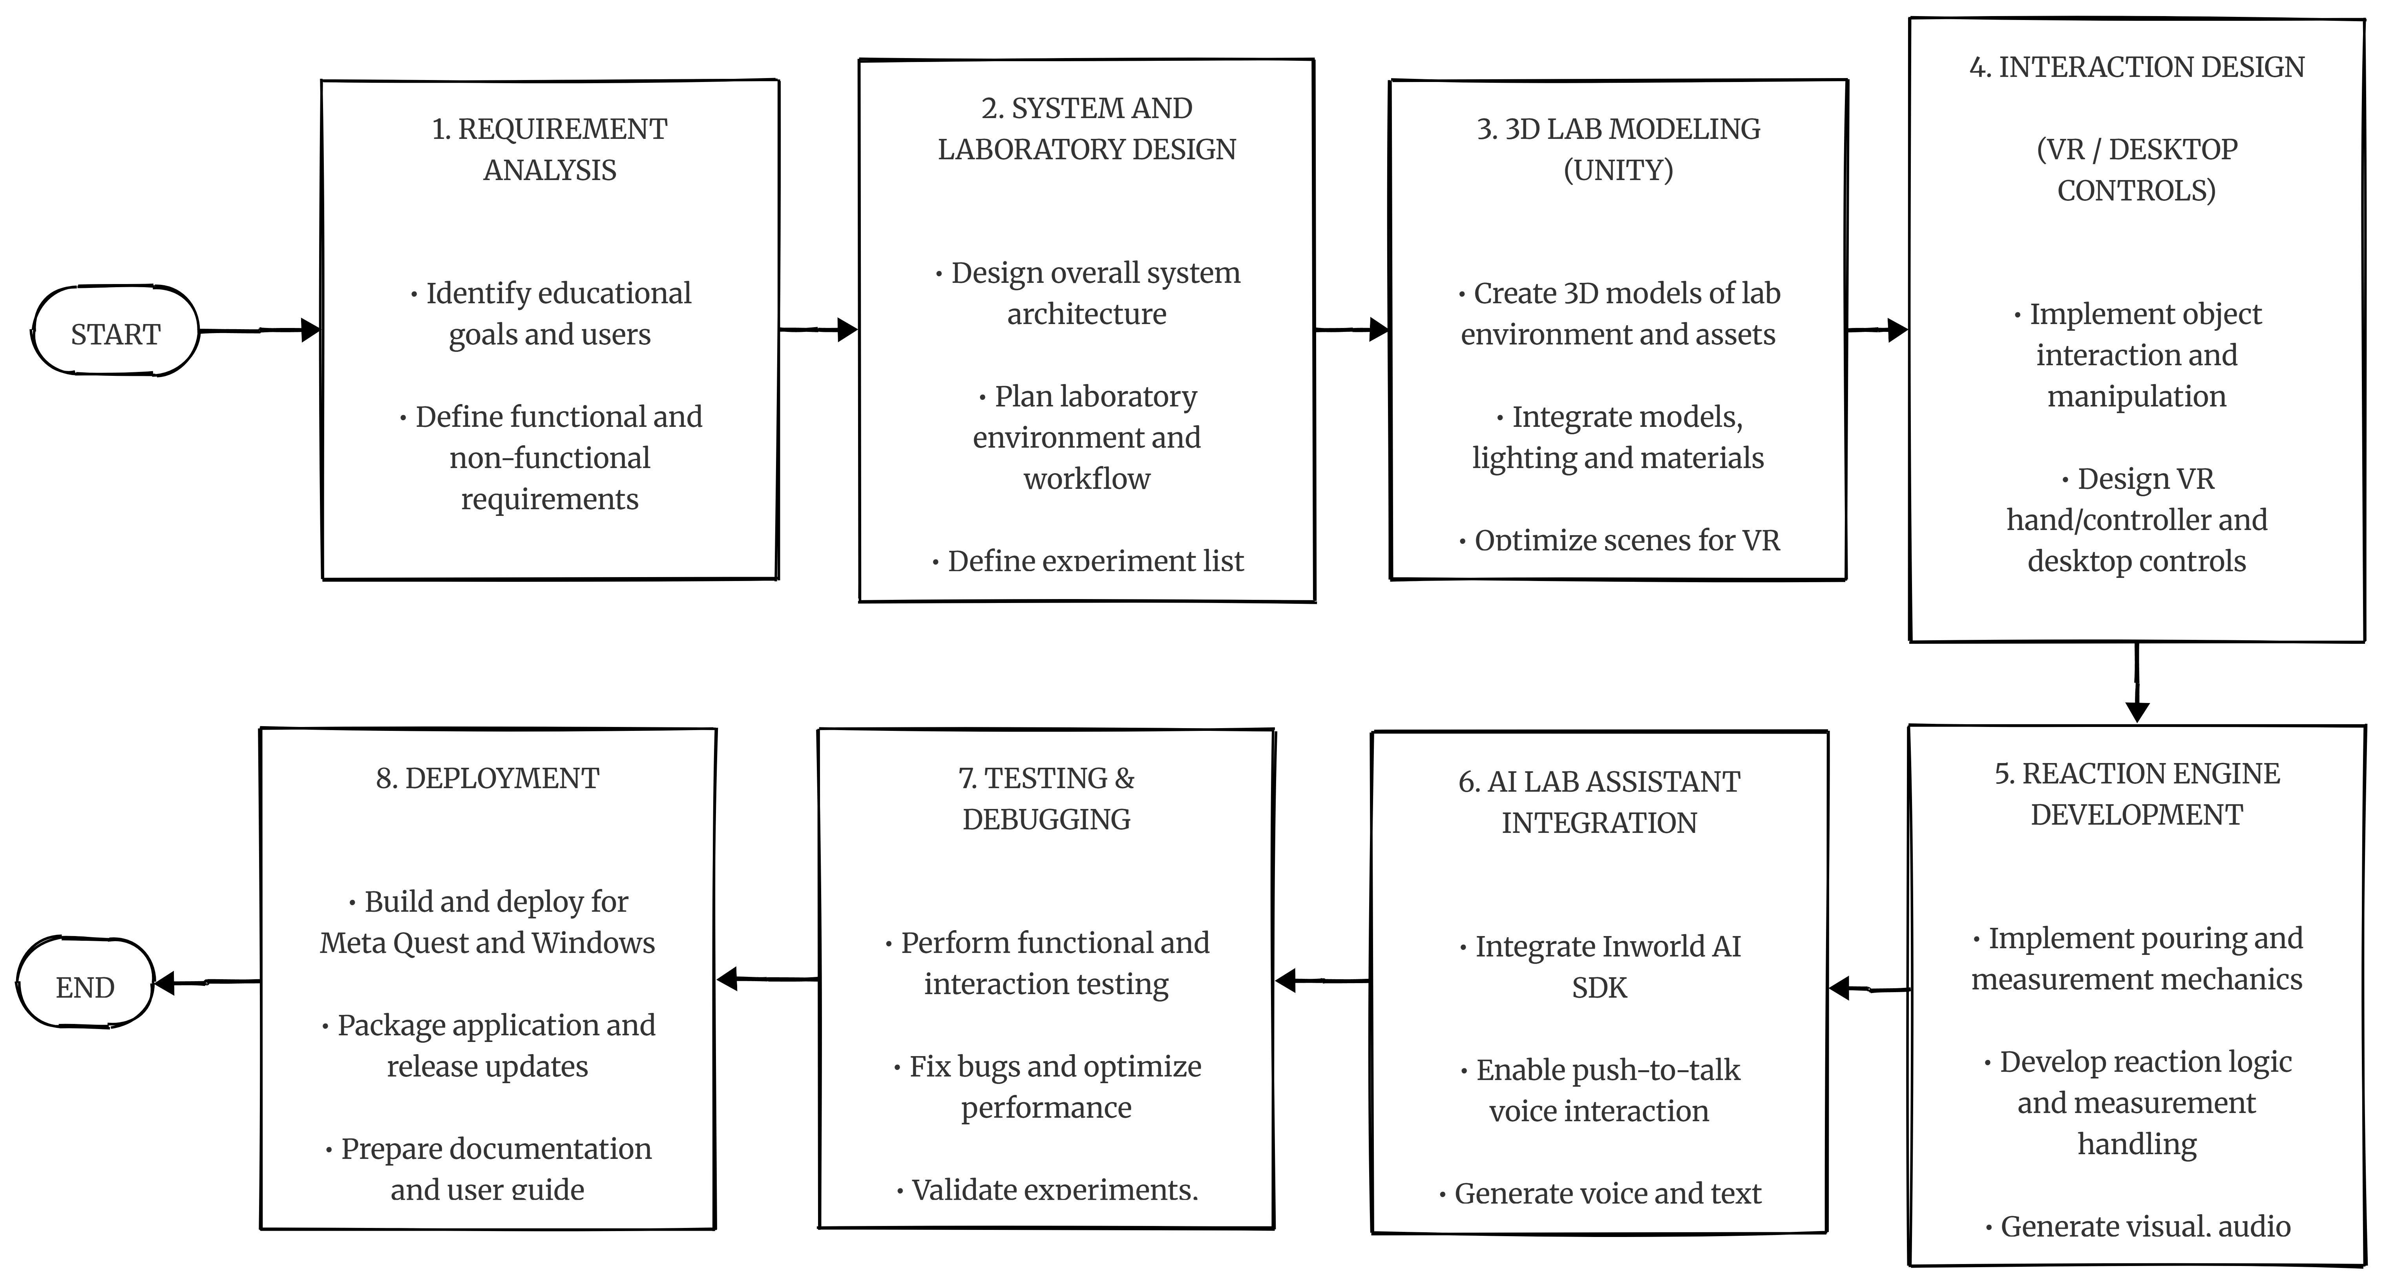
Fig. 1. Illustrates the development method for Atomix.
B. Research Queries
According to the suggested approach to development and educational aims of the system, the following research queries are formulated:
Q1: In what way can the development of a virtual chemistry laboratory be executed so that it successfully involves interactive experiments, teaching visualization, and evaluation in a comprehensive educational context?
Q2: In what way can both Virtual Reality technology and desktop interaction be used in chemistry education while ensuring flexibility of the access to laboratory activities?
Q3: In what way can conversational AI be applied to a virtual laboratory of chemistry in order to get extra assistance in learning chemistry?
Q4 In what manner has Atomix managed to meet the essential functional and educational specifications that were developed for the virtual chemistry lab?
While the first three research questions pertain to the design and integration of the critical parts of Atomix, the fourth question is aimed at assessing the outcome of the created prototype from the point of view of system and learning design.
- IMPLEMENTATION
A. Ideation Phase
In the ideation phase, the key learning and functional aims of Atomix were determined. The key idea was to create a virtual laboratory for chemistry experiments that could be performed by students interactively in three dimensions. The main purpose of the system was to support virtual reality immersion while making it possible for the users to utilize regular keyboard and mouse setups in case VR headsets are unavailable.
The main educational aim of the system was to reveal theoretical concepts of chemistry through practice. Rather than present chemical reactions in written forms or through static images, Atomix allowed the users to select an experiment, interact with laboratory equipment, and perform the experiment steps they had to take in order to see the outcomes of their work.
A secondary aim of the ideation phase was instructional support before and during experimentation. The design introduced a concept called learn-before-perform. This means that the learner is able to see an explanatory video that illustrates chemical processes on a molecular level before starting an experiment. The solution also included audio guidance and documentation of the experiment in the course of practical work.
The idea has been further developed with the incorporation of an AI Lab Assistant that is designed for voice interaction. The aim of this component is to provide conversational help whenever any chemistry-related questions arise. The assistant is able to interpret voice input.
At the end, Atomix is able to provide students with assessments. In addition to practical experiments, the program is capable of providing a number of randomized theoretical and practical tasks in a separate testing environment. Therefore, the application is developed as a virtual laboratory and environment for practicing chemistry.

B. Phase of Conceptualizing Ideas
During the phase of conceptualizing ideas, the educational goals were turned into a structured interaction model for the virtual lab. The user begins at the main screen and may choose between the practice lab, testing area, or the AI Lab Assistant. The working process in this lab is based on a chemistry textbook, allowing the student to read and select an experiment they are interested in.
Having selected an experiment, the student views the option of using the instructional material first or going straight to the practical task. During the practical task, the lab comprises the equipment and chemical elements necessary for the experiment chosen. The student then carries out the experiment by manipulating the virtual objects available in the environment.
In the desktop mode, the same lab visuals are adjusted through the keyboard and mouse. The desktop adaptation involves the use of first-person control, as well as a center-screen interaction system and object grabbing possibility.
The designed reaction model employs the interaction system’s usage of a state-based communication. Pouring actions are identified through object interactions. Then, the acquired trigger information is used for the reaction system to produce the audio-visual feedback. Hence, the reaction system mirrors the chemical reaction and its effects while following the requirements for engagement in laboratory experiments.
At the conceptualizing phase, the instructional media has also been defined. The videos on molecular explanation are presented using a suitable learning interface, while the experiment sheets and audio instructions provide the required procedural information. The evaluation environment was developed separately, making it possible to produce and evaluate both practical reacting tasks and theoretical multiple-choice questions.
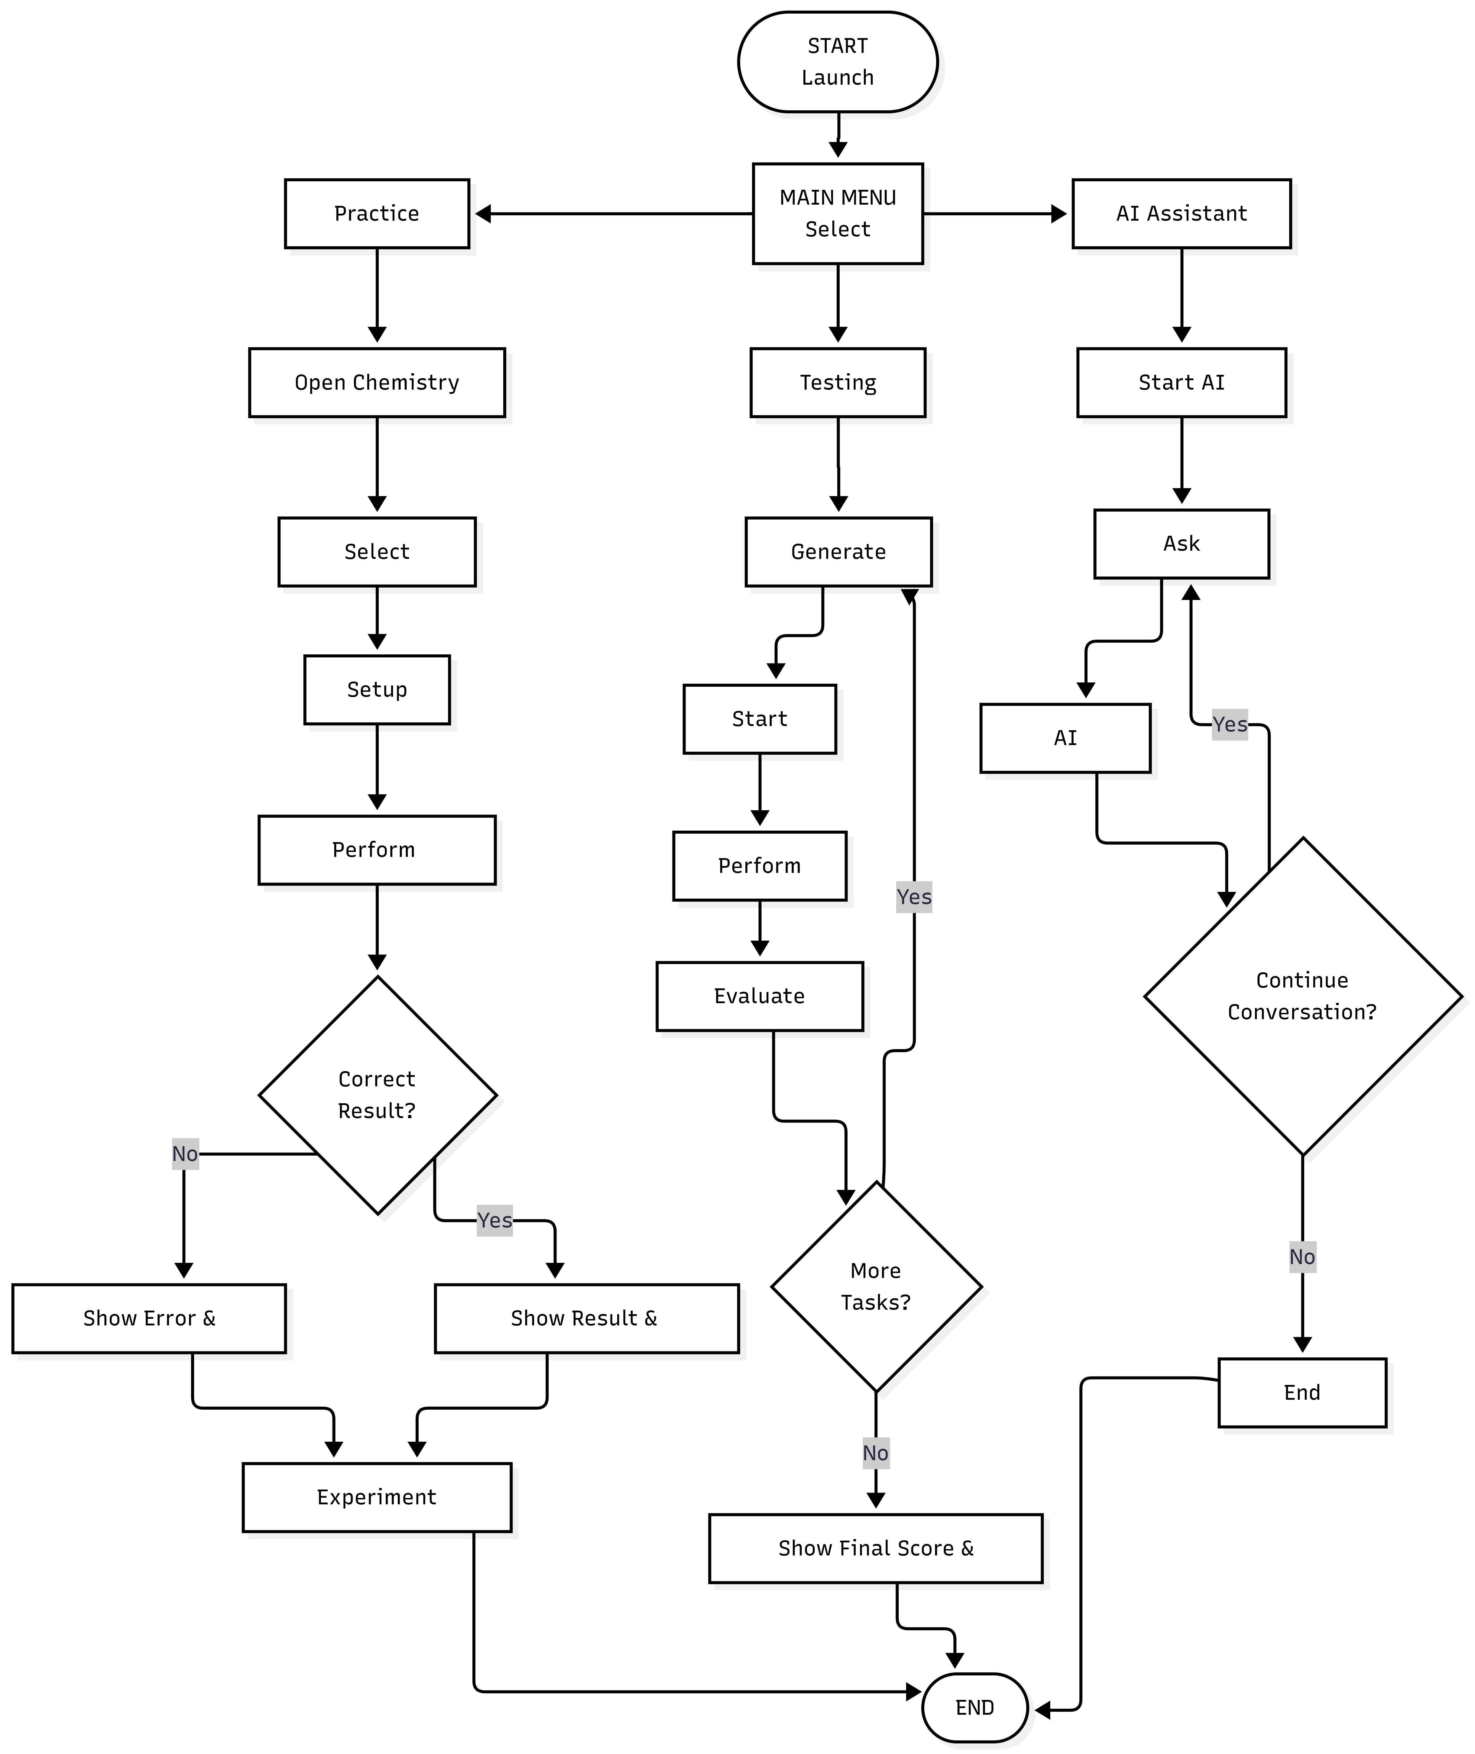
Fig. 2. The Atomix user process is outlined through three stages: Practice, Testing, and Lab Assistant.
The workflow created helps to integrate three main aspects of the service: practical experiment, test, and conversation.
C. Prototyping Stage
The prototyping stage made it possible to switch from concept design to practical existence in the form of a program made in Unity. The Atomix software has been developed using Unity 6000.3.7f1, along with Built-in Render Pipeline and XR compatibility used for MetaQuest and OpenXR. The program consists of four main screens: the main menu, laboratory setting, testing stage, and Lab Assistant setting.
The laboratory setting was created using 3D laboratory models and interactive devices. The reaction system has the scripts for the eight carried out experiments and pouring plus interaction facilities. When required conditions for interaction are fulfilled, the relevant reaction starts and the program displays visual effects, audio feedback, and chemical details.
A reaction-selection feature introduced to the system utilising the world-space UI. Learner completes its travels through the reaction category sections before deciding on the preferred experiment. The system activates the laboratory equipment for the selected experiment while disabling all associated objects for other experiments.
The learn-before-perform capability was executed through the video playback feature provided by Unity. Reaction-specific video clips are linked to identifiers obtained through a ScriptableObject-based video catalog. The video of the learned reaction will be presented to the user upon choosing the learn option.
The AI Lab Assistant was developed using the Inworld AI Unity SDK. The push-to-talk approach enables recording the user voice and transmitting it to the Inworld service generating the answer that appears as voice and text messaging form.
The assessment system comprises three main components including task generation, theoretical questions, and countdown. Practical and theoretical questions used in assessments can be randomized thus enabling the application to generate different sequences of questions each time.
The running desktop adaptation platform has also been established to allow the VR-friendly laboratory environments to function by using keyboard and mouse too. The desktop implementation automatically assigns the functionality of first-person controller, object manipulation, crosshair-based targeting, and similar interaction aspects upon activation of the application without the XR interaction framework.
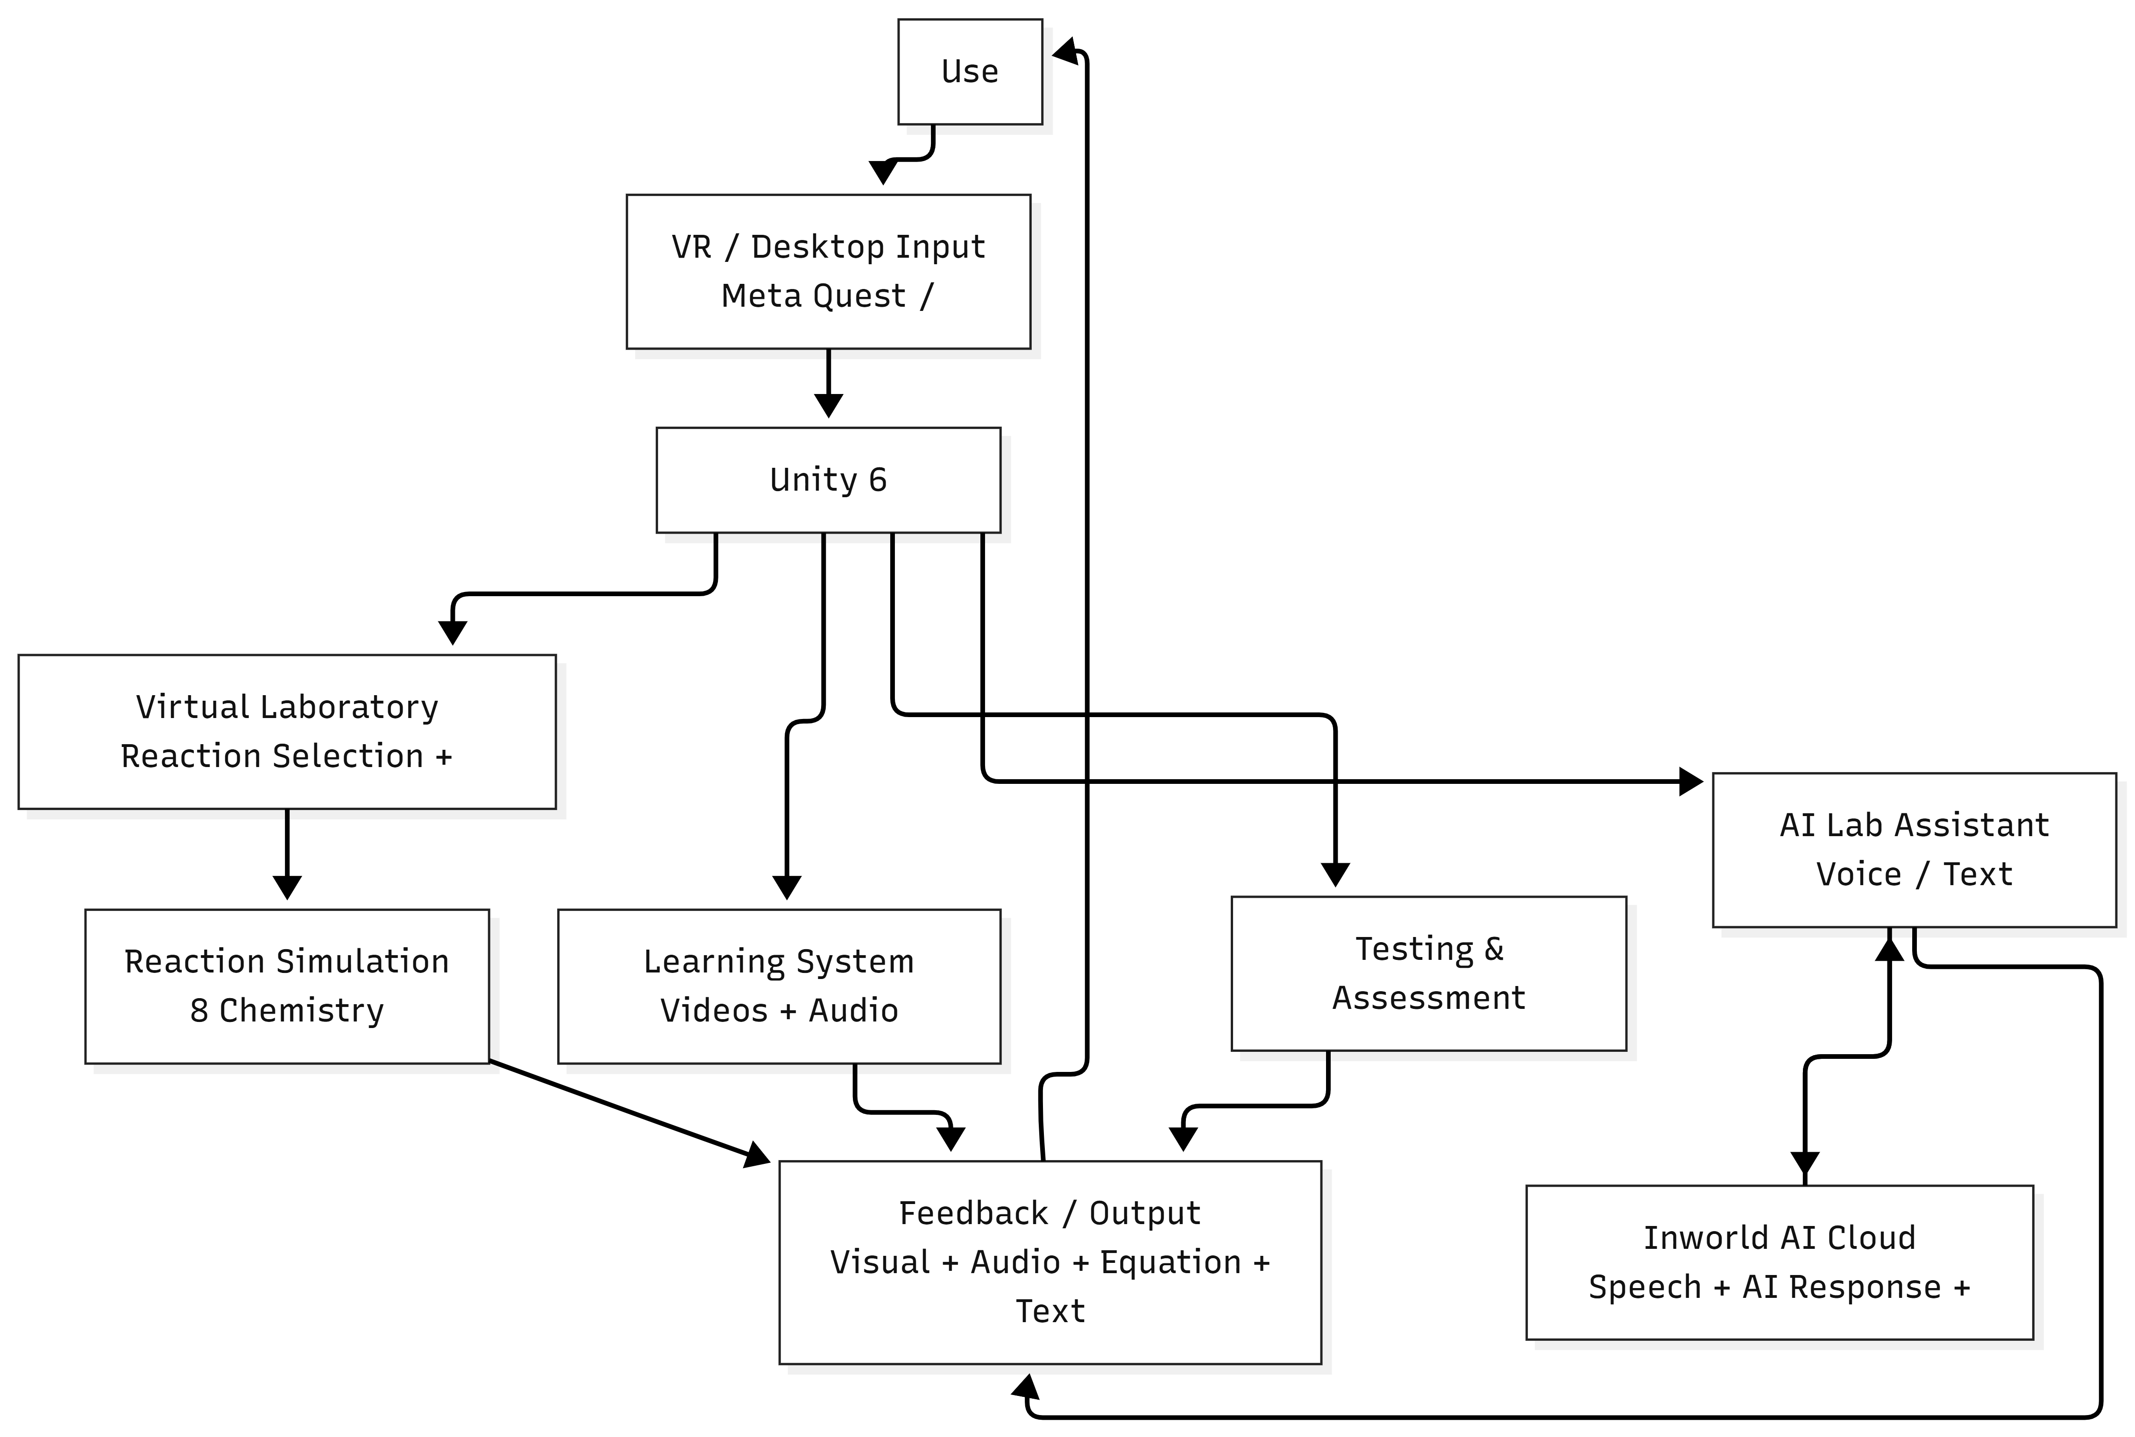
Fig. 3. Shows the high-level design of the Atomix system.

The integrated prototype system incorporates various modules like the virtual laboratory, interaction system, reaction engine, instructional content, evaluation system, AI lab assistant, and bi-platform interaction into a single Unity application.
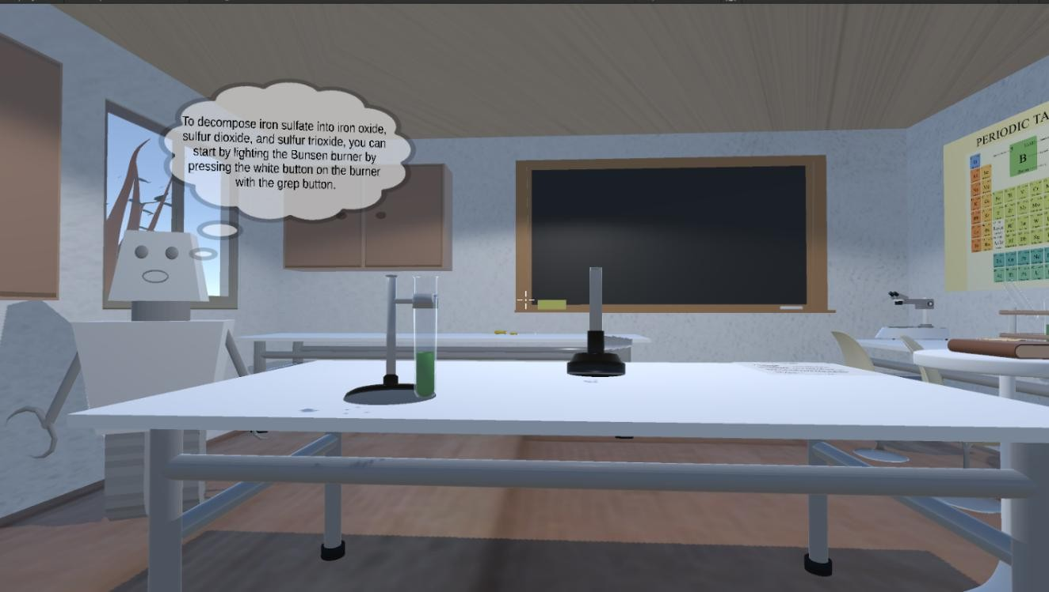
Fig. 4. Shows the virtual chemistry lab in 3D.
The finished prototype presents an interactive platform for the users to select experiments, manipulate lab equipment, watch results of the reactions, view instructional materials, communicate with the AI lab assistant, and touch upon practical and theoretical evaluation tasks.
- Result and Discussion
The Atomix prototype was tested for its functional integration, interaction support, educational features, and accessibility. The finished system effectively puts together eight real chemistry experiments, ten tests of theory, molecular-level education materials, documentation, audio instructions, A conversational AI Lab Assistant, and the use of VR and keyboard-and-mouse interface within a single Unity programme. All functional parts correspond to the main functional requirements established in the methodology.
The outcomes show that the suggested laboratory process is capable of supporting an entire learning cycle from the selection of the experiment to its implementation. Users are able to select an experiment with the use of the reaction book, check the learning material before performing the experiments, operate the equipment needed in the laboratory, and receive feedback in the form of visual, audio, and chemical equations. The learn-before-perform principle includes videos explaining molecular science and experiment sheets combined with audio guidance, enabling users to obtain both conceptual and procedural assistance in one environment. Another outcome is the implementation of the experiment with sodium and water that considers the quantity elements of the experiment, as the volumes of water and mass of sodium are monitored during the experiment and compared with the predetermined tolerance limits.
The prototype exhibits an adaptive interface through its advanced dual-access technology. Both the laboratory scenes for Meta Quest/OpenXR and the standard keyboard-and-mouse desktop environment can communicate with the reality created through runtime adaptation. Moreover, by incorporating eight practical reaction activities and ten theoretical inquiries, the testing framework pushes the limit of the system development past simulation, enabling both procedural and theoretical aspects of the knowledge to be examined through Atomix. The AI Lab Assistant via push-to-talk voice communication as well as produced messages via voice or writing offer another communicational channel.
In general, the results show the success of implementation of all the basic elements presented in the research methodology in the prototype. Nevertheless, the outcomes show a technical and functional viability, not the actual validity of learning outcome. The project does not include any controlled empirical study or analysis of learning improvements, thus, the claims that students work more effectively cannot be proved at the moment.
- Conclusion and Future Works
Atomix, an interactive virtual chemistry laboratory has been presented in this research. Atomix combines several principles of functioning of laboratory experiments together with instructional visualization, assessment, Virtual Reality, desktop interaction, and conversational Artificial Intelligence. The prototype developed by researchers facilitates eight real experiments in the field of inorganic chemistry, ten tasks aimed at theoretical assessment, and a number of other functions, among them educational videos and instructions used during experiments.
The prototype is able to bring together all these functions and be transformed into the learning process as a functional laboratory which consists of the following phases: initial learning of the experimental procedure and theoretical background, performing the experiment, obtaining feedback, and further evaluating knowledge. However, there are still no reliable data on the effectiveness of the prototype created by the researchers and no reliable evidence of the learning effect it provides.
In the future, the team will strive to broaden the spectrum of their library of reactions and to convert the existing framework of reactions into an enhanced data-driven system. The tasks will include tracking student advancement, applying learning analytics, providing location-sensitive AI assistance based on the student's experimental progress, creating rest of molecular-learning videos, and optimizing the performance of the VR product. It is also necessary to conduct user studies aimed at usability assessment and executing both pre- and post-learning measurements so that the impact of Atomix from the educational perspective is determined practically.
VII . References

[1] S. Ramos, E. P. Pimentel, M. das G. B. Marietto, and W. T. Botelho, “Hands-on and virtual laboratories to undergraduate chemistry education: Toward a pedagogical integration,” in 2016 IEEE Frontiers in Education Conference (FIE), 2016, pp. 1–8, doi: 10.1109/FIE.2016.7757580.

[2] M. Agarwal and S. Saha, “Learning chemistry through puzzle based game: Atoms to molecule,” in 2011 9th IEEE International Conference on Emerging eLearning Technologies and Applications (ICETA), 2011, pp. 189–193, doi: 10.1109/ICETA.2011.6112613.

[3] A. L. Sánchez-López, O. R. Camacho-Ornelas, L. M. Lozano-Sánchez, M. F. Rivas-Gastelum, A. Parra-Córdova, and Y. P. Avalos, “Enhancing chemistry laboratory teaching through gamification: The IQ-Mobile Race,” in 2023 IEEE International Conference on Teaching, Assessment and Learning for Engineering (TALE), 2023, pp. 1–4, doi: 10.1109/TALE56641.2023.10398328.

[4] J. T. Bell and H. S. Fogler, “The application of virtual reality to (chemical engineering) education,” in Proceedings of the IEEE Virtual Reality Conference (VR 2004), 2004, pp. 217–218, doi: 10.1109/VR.2004.1310077.

[5] Y. Luo, P. Guo, S. Hasegawa, and M. Sato, “An interactive molecular visualization system for education in immersive multi-projection virtual environment,” in Proceedings of the Third International Conference on Image and Graphics (ICIG), 2004, pp. 485–488, doi: 10.1109/ICIG.2004.36.

[6] T. Xie, Y. Li, and Y. Tang, “Effects of using immersive virtual reality for science education on learning outcomes: A randomized controlled pilot study,” IEEE Transactions on Learning Technologies, vol. 16, no. 6, pp. 1045–1056, 2023, doi: 10.1109/TLT.2023.3263587.

[7] N. Sandu and E. Gide, “Adoption of AI-chatbots to enhance student learning experience in higher education in India,” in 2019 18th International Conference on Information Technology Based Higher Education and Training (ITHET), 2019, pp. 1–5, doi: 10.1109/ITHET46829.2019.8937382.

[8] M. P. Kurniawan, M. Suyanto, E. Utami, and Kusrini, “Educational game learning quality evaluation tool: A systematic literature review,” in 2024 7th International Conference on Informatics and Computational Sciences (ICICoS), 2024, doi: 10.1109/ICICoS62600.2024.10636925.

[9] J. Gilbert and D. Treagust, “Multiple representations in chemical education,” 2009, doi: 10.1007/978-1-4020-8872-8.

[10] H.-K. Wu, J. Krajcik, and E. Soloway, “Using technology to support the development of conceptual understanding of chemical representations,” 2000.

[11] E. Byusa, E. Kampire, and A. Mwesigye, “Game-based learning approach on students’ motivation and understanding of chemistry concepts: A systematic review of literature,” 2022, doi: 10.1016/j.heliyon.2022.e09541.

[12] N. Ali and S. Ullah, “Review to analyze and compare virtual chemistry laboratories for their use in education,” 2020, doi: 10.1021/acs.jchemed.0c00185.

[13] J. Álvarez Ramírez and A. Bueno, “Learning organic chemistry with virtual reality,” 2020, doi: 10.1109/ICEV50249.2020.9289672.

[14] I. Atmosukarto, W. S. Cheow, P. Iyer, N. Tong, and K. Yu, “Enhancing adaptive online chemistry course with AI-chatbot,” 2021, doi: 10.1109/TALE52509.2021.9678528.

